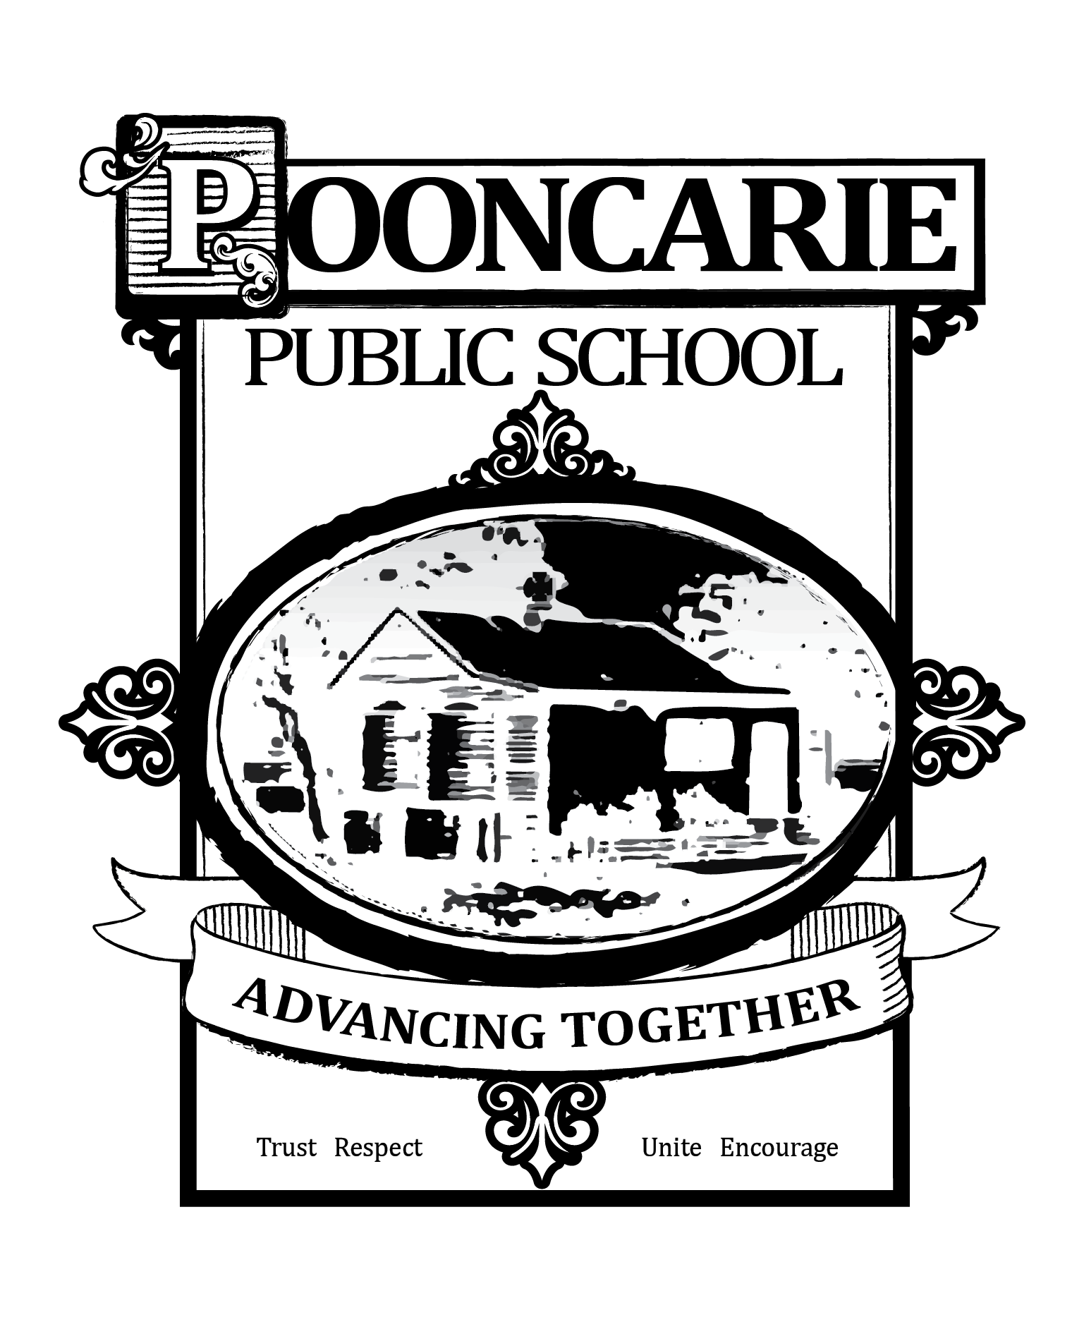
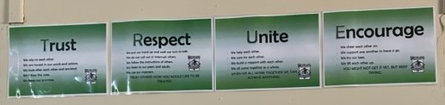

Pooncarie Public School;
School Behaviour Support
and Management Plan
This plan is an operational document which outlines school processes and practices, is published on the school website and is made available to all students, parents/carers and school staff.
Overview
Pooncarie Public School is committed to explicitly teaching and modelling positive behaviour and to supporting all students to be engaged with their learning. Key programs prioritised and valued by the school are our Merit System, Zones of Regulation, Growth Mindset and Social Emotional Learning.

Promoting and reinforcing positive student behaviour and school-wide expectations

Pooncarie has the following school-wide rules and expectations:
- We are Trustworthy
- We are Respectful
- We are United
- We are Encouraging

Pooncarie Public School uses the following strategies and systems to explicitly teach, recognise and reinforce positive student behaviour and behavioural expectations:

Pooncarie Public School Merit System
- Awesome Awards are awarded to students demonstrating positive behaviours in the classroom, playground or during School activities
- Reading Awards m ay be awarded students for 25 Nights, 50 Nights, 75 Nights, 100 Nights, 125 Nights, 150 Nights, 200 Nights.
- Implementation of the Whole School Wellbeing Framework
- Explicitly Teaching ‘Positive Values’
- Weekly targeted wellbeing lessons based on school values, Zones of Regulation, Social Emotional Learning, Growth Mindset and PBL

Behaviour Code for Students

The Behaviour Code for Students can be found at https://education.nsw.gov.au/policy-library/policies/pd-2006-0316/pd-2006-0316-01. High expectations for student behaviour are established and maintained through effective role modelling, explicit teaching and planned responses.

Whole School Approach
Care Continuum | Strategy or Program | Details | Audience
Prevention | Wellbeing Framework  School Value System  School merit system  PD/H/PE  Classroom Management  Transition | The School’s Wellbeing Framework System is based on personal responsibility, respect, a genuine partnership between the student, the family and the School to build relationships, these are fundamental components of the School ’s Student Welfare and Management Framework.  Values explicitly taught. Students are recognised for exhibiting values.  Awesome Awards for demonstrating positive behaviours in the classroom, playground or during School activities and Reading Awards  All students are explicitly taught according to our scope and sequence- based on Zones for Learning, PBL, Social Emotional Learning and Growth Mindset.  Strong classroom management is built through:  -strong teacher/student relationships  -consistent teacher expectations, routines, modelling and responses to behaviour  -high quality, differentiated teaching and learning activities.  Transition occurs between preschool, primary and high school to assist students as they move from one service to the next.  Transition sessions for students requiring additional support are organised based on individual needs. | Whole School  Whole School  Whole School  Whole School  Whole School  Whole School
Early Intervention | Kindergarten Transition | Preschool visits  Parent surveys  1:1 parent meetings  Transitional sessions- additional sessions occur if needed for students requiring further transitions  Kindergarten Social Skills Program | Kindergarten students, families and staff
Targeted Intervention | Learning & Support | Individual student needs are identified and access to school counsellor or specialist allied health professionals supported. | Individual students, families & staff
Individual Intervention | Learning & Support  Attendance  SLSO Support  IEP/PLP  Behaviour management plans | Individual student needs and access to school counsellor or specialist allied health professionals supported. Assessments are completed as needed and applications for integration funding support through Access Request.  Attendance is monitored regularly, with contact being made with parents should there be attendance concerns.  Work with identified students on individual goals from IEP’s  Completed for all students.  Completed for students requiring support | Whole School  Whole School  Individual students  Individual students  Individual students

Detention, reflection and restorative practices
At Pooncarie Public School we engage in restorative practices to address behaviours of concern.
Action | When and how long? | Who coordinates? | How are these recorded?
Teacher- directed time- out  Student utilises a designated space in the classroom | When a student demonstrated escalation of inappropriate behaviour & after de-escalation and teaching practices have been tried.  Length of time-max 10-15 mins  Dependent on the age of the child. | Class Teacher | ERN
Student- directed time- out  Student utilises an agreed calm space in the classroom | When a student determines they need to move themselves from a stressful situation or to prevent escalation in their behaviour. | Class teacher/ student | ERN
Work Catch-up | Where behaviour is minor but causes disruption, the supervising teacher will follow up with the student on work missed during class break | Class teacher/ student | ERN
Reflection | Discuss the issue with the student, talk through the Positive Problem solving procedure in the process of developing resilience and positive problem- solving strategies | Staff/student | ERN

Partnership with parents/carers
Pooncarie Public School will partner with parents/carers in establishing expectations for parent engagement in developing and implementing student behaviour management strategies by discussion with the P&C and parents.
Pooncarie Public School will communicate these expectations to parents/carers by parent discussions, school newsletters, Facebook, school websites and parent-teacher conferences.

School Anti-bullying Plan
Please follow this link for the schools Anti-bullying Plan. In addition, you can refer to the Bullying of Students – Prevention and Response Policy and Anti-bullying Plan.

Reviewing dates
Last review date: 28/03/2023
Next review date: Day 1, Term 1, 2024

