Pooncarie Public School
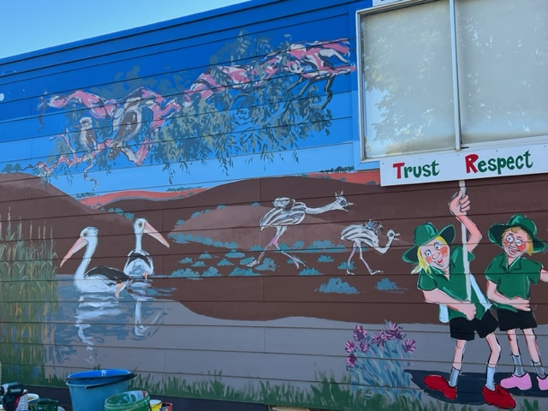
Attendance Procedures
70-82 Tarcoola Street Pooncarie NSW 2648 Phone: 03 50295231 or 03 50295278
Website: pooncarie-p.schools.nsw.gov.au Email: pooncarie-p.school@det.nsw.edu.au
Trust Respect Unite Encourage

The NSW Department of Education takes school attendance very seriously as do we here at Pooncarie Public School.
Student attendance in Government Schools is compulsory and it is the responsibility of Parents and/or Carers to ensure that your child attends school every day. This daily attendance is important for your child to achieve their educational best. When your child attends school every day it means that learning becomes easier and your child can build and maintain friendships with their classmates.

Punctuality and routine are important skills to learn and so arriving at school on time means your child will not miss out on any important learning activities. It is crucial that your child arrives at school before 9:00am. Arriving late at school is considered a partial absence and must be explained by parents/carers in writing.

On occasions your child may be absent from school. Reasons that the Department deem justified for a student absence include:
- Being sick, or having an infectious disease (Medical certificate may be requested)
- Having an unavoidable medical appointment
- Being required to attend a recognised religious holiday
- Exceptional or urgent family circumstances (e.g. attending a funeral)

Any and all absences must be explained in writing to the school by parents and/or carers. Following an absence from school parents/carers must provide an explanation before 7 days have passed. However, the school may contact you for an explanation within 3 days of your child’s absence. To provide a written explanation parents/carer can fill out an Absence Note available from the School Office, email the school, send a text or write a note to your child’s teacher.

Exemption from school may be granted for specific reasons. Parents and carers must formally apply for extended leave from school by completing an Application for Exemption from Attendance at School. A Certificate of Exemption from Attendance at School will be provided for exemptions which are granted. Students with an exemption will not have the days absent counted as part of their attendance record.
The Department does have policies regarding exemption from attendance at school and reasons for granting a full day exemption from attending school may be due to:
- Exceptional circumstances (including the health of the student where sick leave is not appropriate)
- Employment/participation in the entertainment industry or elite arts and/or sporting events.
An Application for Attendance/Enrolment at School form must be completed and approved by the Principal in advance of the missed school days.

Pooncarie Public School recognises that working collaboratively with students and their families is the best way to support the regular attendance of our students. Consequences of frequent unexplained absences, may result in an Application to the Home School Liaison Program and contact with other services and agencies to enhance the effectiveness of interventions with students and families. We will work together to identify and implement strategies to get every student to school.

DoE Education School Attendance policy: https://education.nsw.gov.au/policy-library/policies/school-attendance-policy

Compulsory School Attendance Information for parents: https://schoolsequella.det.nsw.edu.au/file/51561b22-712a-4e98-9873-6a14eae6cac1/1/english-compulsory-school-attendance-parent-brochure.pdf

Student Attendance in Public School Procedures: https://education.nsw.gov.au/content/dam/main-education/policy-library/associated-documents/pd-2005-0259-02.pdf

Exemption from School Procedures
https://education.nsw.gov.au/policy-library/associated-documents/exempt_gui.pdf

Exemption from school FAQs: https://education.nsw.gov.au/content/dam/main-education/en/home/inside-the-department/attendance-resources/Exemption_from_School_Procedures_%E2%80%93_FAQs_to_provide_clarity_and_assist_implementation.pdf

